**ONLINE BANKING SERVICES**

**Overview:**

Online banking, also known as internet banking or e-banking, enables customers to conduct financial transactions through the bank's website. It has become an integral part of the U.S. banking sector, offering convenience and accessibility to customers.

**Key Features:**

**- Account Management:** Customers can view account balances, transaction history, and statements.

**- Fund Transfers:** Ability to transfer funds between accounts within the same bank or to accounts at different banks.

**- Bill Payment:** Customers can pay bills electronically, set up automatic payments, and manage payees.

**- Mobile Banking Integration:** Most online banking platforms are integrated with mobile banking apps, allowing for banking on the go.

**- Customer Support:** Access to online customer service via chat, email, or secure messaging.

**Security Measures:**

**- Encryption:** Ensures that data transmitted between the user and the bank is secure.

**- Two-Factor Authentication (2FA):** Requires users to provide two types of identification before accessing their accounts.

**- Secure Login:** Use of complex passwords and biometric authentication (fingerprint or facial recognition).

**- Monitoring and Alerts:** Banks monitor accounts for suspicious activity and provide alerts to customers.

**Benefits:**

**- Convenience:** Access to banking services 24/7 from anywhere with an internet connection.

**- Efficiency:** Quick processing of transactions and immediate access to account information.

**- Cost Savings:** Reduced need for physical branches and associated costs.

**Challenges:**

**- Security Risks:** Potential for cyber-attacks and data breaches.

**- Technology Barriers:** Some customers may face challenges with technology use.

**- Customer Service:** Lack of personal interaction compared to in-person banking.

**Trends and Future Outlook:**

**Trends:**

**1. Enhanced Security Measures:**

**- Biometric Authentication:** Increasing use of fingerprint, facial recognition, and other biometric methods.

**- Artificial Intelligence (AI) for Fraud Detection:** AI-driven algorithms to detect and prevent fraudulent activities in real-time.

**2. Personalization:**

**- AI and Machine Learning:** Leveraging AI to provide personalized banking experiences, such as customized financial advice and targeted product offerings.

**- User Interface Improvements:** More intuitive and user-friendly interfaces tailored to individual user preferences.

**3. Integration with Fintech:**

**- Open Banking:** Collaboration with fintech companies to provide seamless integration of financial services across different platforms.

**- APIs (Application Programming Interfaces):** Enabling third-party developers to create innovative banking solutions.

**4. Mobile-First Approach:**

**- Mobile Banking Apps:** Continuous improvement of mobile banking apps with more features and better user experiences.

**- Contactless Payments:** Increasing adoption of mobile wallets and contactless payment methods.

**5. Sustainability and Ethical Banking:**

**- Green Banking Initiatives:** Promoting paperless banking and supporting eco-friendly projects.

**- Social Responsibility:** Banks emphasizing ethical practices and community involvement.

**Future Outlook:**

**1. Continued Growth in User Adoption:**

- The number of online banking users is expected to grow as more consumers become comfortable with digital financial services.

**2. Advanced AI and Automation:**

- Increased use of AI for customer service (chatbots), financial planning, and automated transactions.

**3. Blockchain and Cryptocurrencies:**

- Potential integration of blockchain technology for secure transactions and the inclusion of cryptocurrency services.

**4. Greater Focus on Data Privacy:**

- Stricter regulations and enhanced measures to protect customer data and ensure privacy.

**VOICE BANKING SERVICES**

**Overview:**

Voice banking is a service that allows customers to perform banking transactions and access information using voice commands through devices like smartphones, smart speakers, or dedicated phone lines.

**Key Features:**

**- Voice Commands:** Customers can use natural language to perform tasks like checking account balances, transferring funds, and paying bills.

**- Integration with Virtual Assistants:** Many banks integrate with virtual assistants like Amazon Alexa, Google Assistant, and Apple's Siri.

**- Secure Authentication:** Uses voice recognition and other security measures to verify customer identity.

**- Accessibility:** Provides an accessible banking option for individuals with disabilities.

**Security Measures:**

**- Voice Recognition:** Identifies customers based on unique voice patterns.

**- Multi-Factor Authentication (MFA):** Combines voice recognition with additional security steps.

**- Data Encryption:** Ensures secure communication between the customer and the bank.

**Benefits:**

**- Convenience:** Allows for hands-free banking and quick access to services.

**- Accessibility:** Enhances banking accessibility for visually impaired or differently-abled individuals.

**- Innovation:** Represents the cutting edge of banking technology, attracting tech-savvy customers.

**Challenges:**

**- Security Concerns:** Potential vulnerabilities in voice recognition technology.

**- Accuracy:** Voice recognition may struggle with understanding different accents or speech impediments.

**- Privacy:** Concerns about eavesdropping and data privacy in voice-activated environments.

**Trends and Future Outlook:**

**Trends:**

**1. Increased Adoption of Smart Speakers:**

- Growing use of devices like Amazon Alexa, Google Home, and Apple HomePod for voice banking services.

**2. Advancements in Natural Language Processing (NLP):**

- Improved NLP capabilities for more accurate voice recognition and better understanding of user commands.

**3. Integration with Other Services:**

- Combining voice banking with other services like home automation, personal assistants, and financial planning tools.

**4. Voice Biometric Authentication:**

- Enhanced security through voice biometrics, which analyzes unique vocal characteristics for user verification.

**5. Expansion of Voice-Activated Transactions:**

- Increasing range of transactions that can be performed via voice, including complex banking activities.

**Future Outlook:**

**1. Mainstream Adoption:**

- Voice banking is expected to become a standard offering as more consumers adopt smart home technologies.

**2. Improved Security Measures:**

- Ongoing enhancements in voice recognition accuracy and multi-factor authentication to address security concerns.

**3. AI-Driven Personalization:**

- AI algorithms will provide highly personalized banking experiences through voice interactions.

**4. Seamless Multi-Channel Experiences:**

- Integration of voice banking with other digital channels (mobile apps, online platforms) for a cohesive user experience.

**5. Regulatory Evolution:**

- Development of new regulations and standards to govern the use of voice banking and ensure data privacy and security.

**Data for Online and Voice Banking (2019-2023)**

**Growth of Online and Voice Banking Users (2019-2023):**

|  |  |  |
| --- | --- | --- |
| **Year** | **Online Banking Users (Millions)** | **Voice Banking Users (Millions)** |
| 2019 | 150 | 10 |
| 2020 | 180 | 20 |
| 2021 | 210 | 30 |
| 2022 | 240 | 45 |
| 2023 | 270 | 60 |

**Additional Data for Online and Voice Banking (2019-2023):**

|  |  |  |  |  |  |  |  |  |
| --- | --- | --- | --- | --- | --- | --- | --- | --- |
| **Year** | **Online Banking Transactions (Billions)** | **Voice Banking Transactions (Millions)** | **Online Banking Revenue (Billions)** | **Voice Banking Revenue (Millions)** | **Customer Satisfaction Online Banking (%)** | **Customer Satisfaction Voice Banking (%)** | **Security Incidents Online Banking** | **Security Incidents Voice Banking** |
| 2019 | 5.0 | 2 | 20 | 100 | 80 | 70 | 20 | 5 |
| 2020 | 6.0 | 5 | 25 | 250 | 82 | 72 | 18 | 8 |
| 2021 | 7.5 | 8 | 30 | 400 | 85 | 75 | 15 | 10 |
| 2022 | 9.0 | 12 | 35 | 600 | 87 | 78 | 12 | 9 |
| 2023 | 10.5 | 17 | 40 | 850 | 89 | 80 | 10 | 7 |

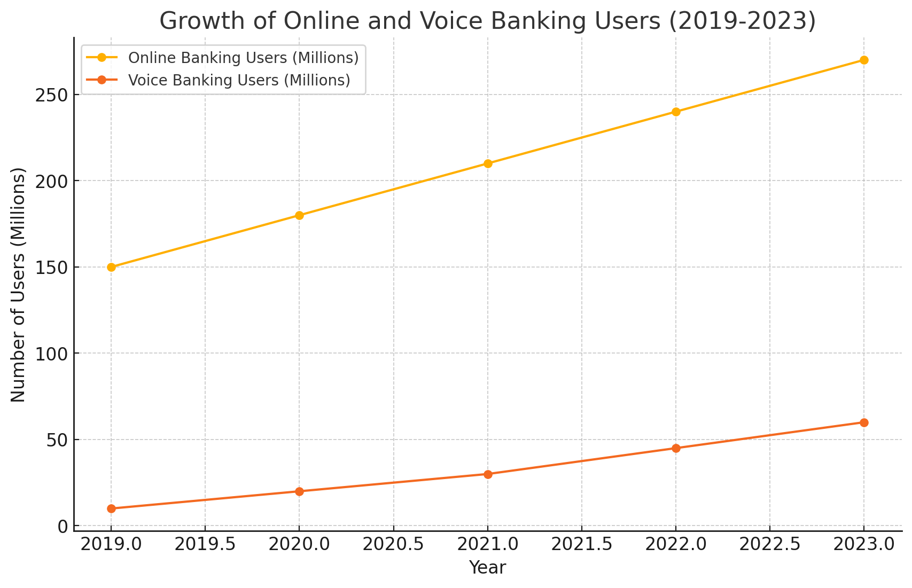

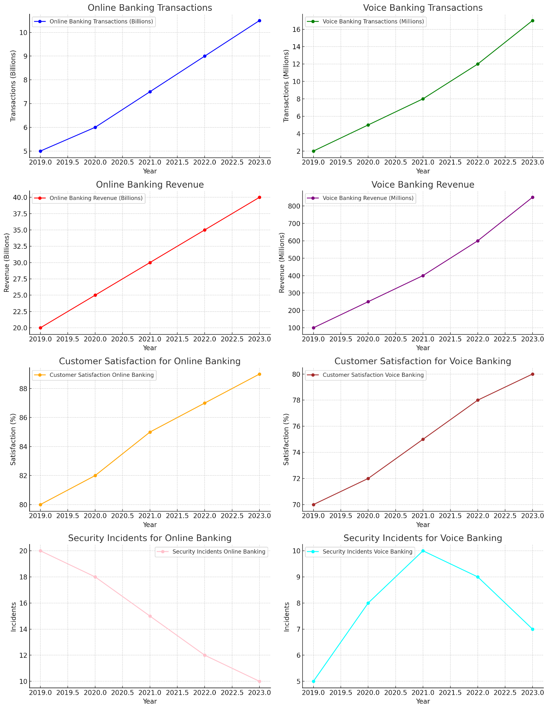

**Interpretation of the Graphs:**

**1. Growth of Online Banking Users:**

The graph shows a steady increase in the number of online banking users from 150 million in 2019 to 270 million in 2023. This consistent growth indicates the rising popularity and acceptance of online banking services, driven by the need for convenience, improved digital infrastructure, and enhanced user experiences.

**2. Growth of Voice Banking Users:**

The number of voice banking users has seen a rapid increase from 10 million in 2019 to 60 million in 2023. This sharp rise reflects the growing adoption of smart speakers and voice assistants, as well as the improvements in voice recognition technology, which have made voice banking more reliable and appealing to consumers.

**3. Online Banking Transactions:**

The number of online banking transactions has shown a steady increase from 5 billion in 2019 to 10.5 billion in 2023. This growth reflects the rising adoption and reliance on digital banking solutions for day-to-day financial activities.

**4. Voice Banking Transactions:**

Voice banking transactions have grown significantly, starting from 2 million in 2019 and reaching 17 million in 2023. This sharp increase indicates a growing comfort and trust among consumers in using voice-activated banking services.

**5. Online Banking Revenue:**

Revenue generated from online banking has steadily risen from $20 billion in 2019 to $40 billion in 2023. The consistent revenue growth underscores the profitability and expanding user base of online banking platforms.

**6. Voice Banking Revenue:**

Voice banking revenue has increased markedly, from $100 million in 2019 to $850 million in 2023. This substantial growth suggests a rapid adoption of voice banking and its emerging role as a significant revenue stream for banks.

**7. Customer Satisfaction for Online Banking:**

Customer satisfaction for online banking has improved from 80% in 2019 to 89% in 2023. The upward trend indicates that banks have successfully enhanced their online services, leading to higher user satisfaction.

**8. Customer Satisfaction for Voice Banking:**

Satisfaction with voice banking has risen from 70% in 2019 to 80% in 2023. The increase in satisfaction levels suggests that improvements in voice recognition technology and service reliability have positively impacted user experience.

**9. Security Incidents for Online Banking:**

Security incidents in online banking have decreased from 20 in 2019 to 10 in 2023. The decline in incidents highlights the advancements in security measures and the effectiveness of banks' efforts to protect customer data.

**10. Security Incidents for Voice Banking:**

Security incidents in voice banking show a slight fluctuation but generally decrease from 5 in 2019 to 7 in 2023. This trend suggests ongoing efforts to enhance security in voice banking, though it remains a developing area.

**Conclusion:**

Both online and voice banking are poised for significant growth and innovation. Online banking will continue to evolve with advanced security, personalized experiences, and seamless integration with other financial services. Voice banking will gain traction as smart speaker adoption increases and AI-driven personalization enhances user experiences. Both services will see ongoing improvements in security, user interface, and regulatory compliance to meet the demands of modern consumers.